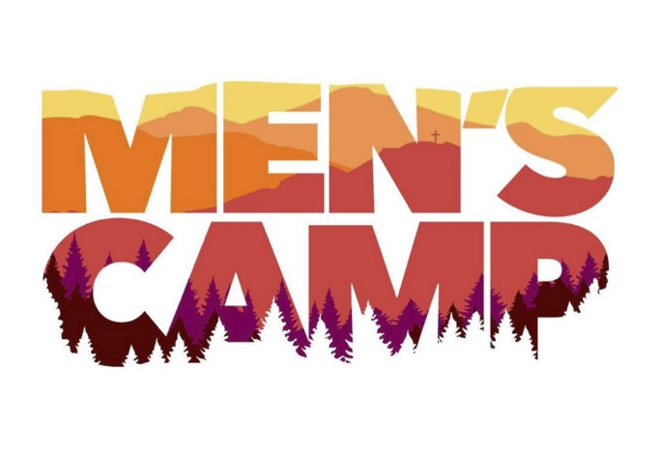
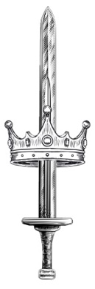
Men
Of
Valor
&

It is time for our first Kingdom Culture Men's Camp!
Friday & Saturday, October 27-28 at Mt. Lemmon.
Please read this entire email as it contains essential information about our time.

Important notes:
- If you have not signed up yet, please do so at: https://kingdomculturecc.org/contact-us/
- A permission slip (included in this email) must be filled out for all minors, even if the parent is attending the camp. No exceptions.
- Minors must be accompanied by an adult at all times. No wandering off.
- Please make us aware of any food allergies
- We are in a natural recreation area and must be mindful not to litter, that all fires are extinguished, and we leave the site the way we find it - leave no trace.
- Fire danger on the mountain is moderate. Be responsible.
- If you have any questions or need special accommodations, contact me at pastors@kingdomculturecc.org

Schedule
Friday 9:00 am - Set Up (Come help if you can)
12:00 pm - Pre-camp prayer
3:00 pm - Arrival Time
6:00 pm - Dinner (grilled steak)
7:30 pm - Campfire worship
8:00 pm - Inspiration & Encouragement
9:00 pm - Hangout time
10:00 pm - Sleep

Saturday 7:00 am - Breakfast (Eggs, potatoes, coffee, OJ)
8:00 am - Worship
8:30 am - Inspiration & Encouragement
10:00 am - Team Building Activity
11:00 am - Final encouragement, group prayer
12:00 pm - Clean / break down camp
2:00 pm - Leave campsite (in the condition we found it in)

What will be provided?
- We have (5) five person tents we are bringing - space in tents are first come, first served.
- Food and beverages (water, dinner, and breakfast)
- The word of God, fellowship, and activities

What do I need to bring?
- Sleeping bag
- Change of clothes
- Hiking shoes / boots
- Tent or hammock (optional)
- Sleeping mat or cot (optional)
- Any dietary needs (special food for allergies, etc.)
- Hygiene products & prescription medications

Location
Campsites are first come, first serve so I will try to get there as early as possible to reserve the site. If the first location is unavailable, then we will move to the second, and then the third. If these are unavailable, then I will hunt to find a workable campsite and will inform everyone via WhatsApp and / or text. (This is why signing up is important so that you can receive updates).

Location #1: Showers Pointe Group Site
E Organization Ridge Rd, Mt Lemmon, AZ 85619
https://www.google.com/maps/place/Showers+Point+Group+Site/@32.4083333,-110.7231305,17z/data=!3m1!4b1!4m9!3m8!1s0x86d6155a8aa1a17b:0xa97f635c9905e8d2!5m2!4m1!1i2!8m2!3d32.4083333!4d-110.7205556!16s%2Fg%2F1tdfcjyr?entry=ttu

Location #2: Whitetail Group Site
11200 Whitetail Rd, Mt Lemmon, AZ 85619
https://www.google.com/maps/place/Whitetail+Campground/@32.4119489,-110.7345193,17z/data=!3m1!4b1!4m6!3m5!1s0x86d6154115d284d9:0x7aa7315561d34ec!8m2!3d32.4119444!4d-110.7319444!16s%2Fg%2F11bx1qs6xj?entry=ttu

Location #3: Spencer Canyon Campground
https://www.google.com/maps/place/Spencer+Canyon+Campground/@32.4169758,-110.7434105,17z/data=!3m1!4b1!4m10!3m9!1s0x86d61515ca1f56fd:0x242e26b2f2f72242!5m3!1s2023-10-27!4m1!1i2!8m2!3d32.4169758!4d-110.7408356!16s%2Fg%2F1vppszdv?entry=ttu

